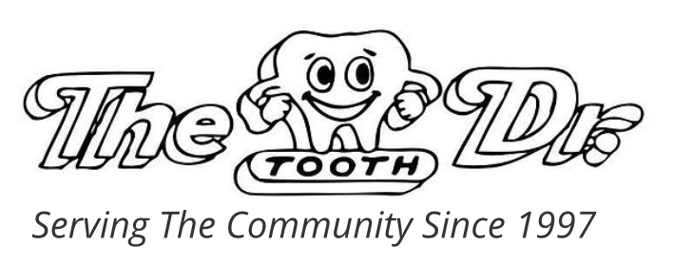

3060 s. Redwood Rd.

SLC, UT 84119

(801) 972-0555

2180 E. Fort Union Blvd.

Cottonwood Heights, UT 84121

(801) 944-4141

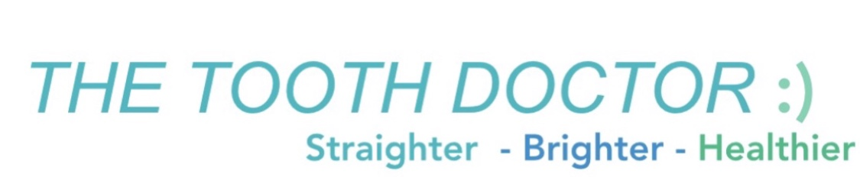

PATIENT FORMS

